BCCTaipei Better Business Awards
Innovation for Wellbeing Award 2024 Guidance and Criteria
- Please provide any supporting documents as separate attachments when you send this application in.
- Please answer the criteria in the space provided in English or Chinese – the space will expand as you type.

Innovation for Wellbeing Award – Application

Company Name (English/Chinese):

Company Website:

Contact Person

Name:

Email:

Phone Number:

Judging Criteria
1 | Provide a concise summary of the innovation, detailing its objectives and the impact on wellbeing. Highlight key features and benefits. (Limit to 500 words)
2 | Submit quantitative and qualitative evidence demonstrating the positive impact of the innovation on people's wellbeing. Emphasize outcomes and measurable impacts rather than activities. (Limit to 1,000 words)
3 | Provide evidence of the long-term sustainability of the innovation, both internally within your organization and externally in the broader community. Discuss ongoing impact and potential for scalability. (Limit to 600 words)
4 | Describe how the innovation is communicated to and engaged with your stakeholder network in accessible and innovative ways. Focus on the effectiveness and creativity of communication strategies. (Limit to 500 words)
5 | Provide a one-page PowerPoint slide summarizing your innovation for wellbeing, highlighting key aspects, objectives, and impacts. (See template below)  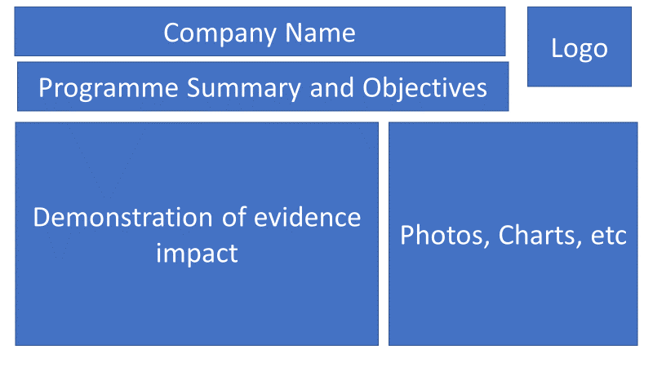
6 | Describe any collaborations or partnerships that were integral to the development and implementation of your innovation. Explain how these relationships contributed to the success and impact of the project. (Limit to 500 words)

Why the Innovation for Wellbeing Award?
As a leading insurer, PCA Life Taiwan’s mission is to be the most trusted partner and protector for this generation and generations to come, by providing simple and accessible financial and health solutions.
The Innovation for Wellbeing Award aligns with PCA Life Taiwan’s mission to enhance people's lives by focusing on the following criteria:
- Focus on Wellbeing: The issues addressed should relate to health and/or wealth.
- Public Interest: Solutions should ideally serve the public interest or assist vulnerable groups, not just employees.
- Innovation Recognition: This award honours companies that develop innovative solutions, including new products, technology, platforms, and services, to improve health, wealth, wellbeing, and sustainability in Taiwan.
- Accessibility: Solutions should be easy to access, affordable for target users, appealing to stakeholders, and provide actionable tools/platforms for active utilization.
This award is open to companies of all sizes, both local and foreign. It considers not only the innovation project but also how it integrates into the business and benefits recipients, employees, and a wider network of stakeholders.

Judging Criteria
The judges will look for applications demonstrating success across the following areas:
- Evaluation of Objectives and Impact
  - The connection between the innovation and the company’s regular business.
  - Initiatives aligned with the goal of innovation for wellbeing, aiming to improve wellbeing and help people live healthier and happier lives.
  - Demonstration of both short-term and long-term impacts.

- Quantitative and Qualitative Evidence
  - The benefits of the initiative to the industry, the company, and stakeholders.
  - Evidence of the innovation being effectively employed.
  - Inclusion of robust quantitative and qualitative evidence.

- Sustainability of the Programme
  - Evidence that the programme can be replicated or scaled up.
  - Evidence of the long-term sustainability of the programme, both externally and internally, and its impact.

- Communication and Innovation
  - How the innovation is communicated throughout the company’s stakeholder network.
  - Effective communication of its impact in accessible and creative ways.

Judging Process
Entries will be evaluated by our Judging Panel, composed of leading experts in their fields, based on the following criteria:
- Concise Summary: A brief summary of the company/individual, including objectives and impact.
- Business Story: A concise outline of the business story, highlighting achievements.
- Relevant Initiatives: Clearly visible initiatives that are relevant to the selected awards category.
- Impact Evidence: Evidence of how these initiatives have transformed your organization and beyond.
The judging panel will shortlist three companies from all entrants. From these, the panel will select a winning company to be announced at the Award Event on 25th September 2024.

How to Submit
Organisations can submit up to two pieces of supporting evidence, explicitly referred to or linked within the submission. Evidence can be attached to the submission form or emailed along with it.
Submissions may include hyperlinks to internal or external websites within the word limit if relevant.
The content of the submission and evidence should cover activities that took place in 2023 and up to June 2024.
Email your application to BBAMarketing@bcctaipei.com by Friday, 16 August 2024.

