BCCTaipei Better Business Awards
Business Leader of the Year Award 2024 Guidance and Criteria
- Please provide any supporting documents as separate attachments when you send this application in.
- Please answer the criteria in the space provided in English or Chinese – the space will expand as you type.

Business Leader of the Year Award – Application

Company Name (English/Chinese):

Company Website:

Contact Person

Name:

Email:

Phone Number:

Judging Criteria
Business Leader Summary

Provide a concise summary of the business leader, detailing their personal objectives and the impact they have made within the organisation. (Limit to 500 words)
Leadership Examples

Provide examples of leadership within your organisation and/or community, highlighting a vision and values that promote diversity, social enterprise, sustainability, and cross-border economic activity through your services, policies, processes, and approaches. (Limit to 1000 words)
Innovative Initiatives

Highlight at least two innovative initiatives, projects, programmes, or services for staff, customers, partners, and the broader community that have received positive feedback, improved outcomes, and created lasting impact. (Limit to 1000 words)
Impact Evidence

Provide evidence of the impact of these initiatives in transforming your organisation and the wider community. (Limit to 600 words)
CSR Programme Objective

Provide a one-page PowerPoint slide summarising your Corporate Social Responsibility (CSR) programme objectives for presentation. (See template below)
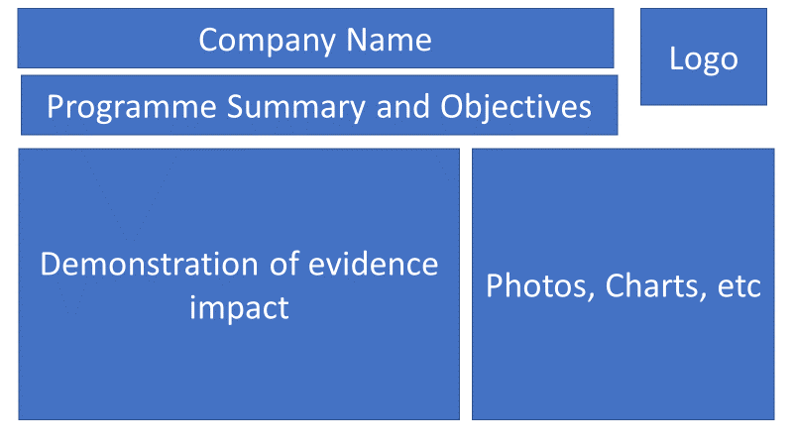

Why a Business Leader Award?
HSBC prides itself on aligning with the highest standards, not only in our products and services but also in our leadership in supporting the community and fostering positive economic development. Sponsoring an award that recognises significant achievements by business leaders in diversity & inclusion, social enterprise, sustainability, and promoting cross-border economic relations is core to our values.

Categories
Admissions will consider the following categories:
- Making a Leadership Contribution & Innovation in Diversity & Inclusion
- Social Enterprise
- Sustainability
- Improving Cross-Border Economic Relations

Category One –
Making a Leadership Contribution & Innovation in Diversity & Inclusion
A diverse and inclusive workforce is critical to running a sustainable and successful business. A business leader should harness the benefits of diverse teams to drive greater innovation, better manage risks, enhance collaboration, and improve workforce agility. Diversity and inclusion principles should be integrated into all aspects of an organisation, helping to attract, develop, and retain the best people while building an inclusive, bias-free environment.
This category invites submissions for a business leader who has consistently demonstrated leadership in advancing the diversity and inclusion agenda within their organisation.

Judging Criteria:
- The nominee champions diversity and inclusion through notable initiatives, actions, and role model behaviour to build a diverse and inclusive environment.
- Evidence of the impact of these diversity and inclusion initiatives in transforming the organisation and beyond.

Category Two – Social Enterprise
Social enterprise uses business methods to solve societal problems and is a growing global trend. A business leader should drive innovative product or service solutions and create a supportive environment for social business development.
This category invites submissions for a business leader who has consistently demonstrated leadership in advancing the social enterprise agenda within their organisation.
Judging Criteria:
- The nominee champions social enterprise through a sustainable business model, initiatives, actions, and role model behaviour to pursue public interest and solve social or environmental problems.
- Evidence of the impact of these social enterprise initiatives in demonstrating realistic economic value and social or environmental solutions.

Category Three – Sustainability
Corporate Social Responsibility (CSR) is an increasingly important part of any company’s vision and strategic direction. A business leader should drive CSR programmes relevant to or integrated with business operations, demonstrating social, environmental, or community impact.
This category invites submissions for a business leader who has consistently demonstrated leadership in advancing the CSR agenda within their organisation.
Judging Criteria:
- The nominee champions CSR through innovative programmes, initiatives, and actions that connect the company’s regular business with stakeholder communication, providing social, environmental, or community impact.
- Evidence of the impact of these CSR initiatives in demonstrating long-term sustainability in social, environmental, and community impact.

Category Four - Improving Cross-Border Economic Relations
Aligned with the mission of the British Chamber of Commerce and the role of multinational organisations operating in Taiwan, this category aims to bring the world to Taiwan and support economic growth for Taiwanese companies abroad.

This category seeks to identify unique and talented individuals who have demonstrated exceptional commitment to driving both inbound and outbound economic growth for Taiwan.
Judging Criteria:
- Championing Cross-Border Economic Relations: The nominee effectively champions cross-border economic relations through innovative programmes, initiatives, and actions. These efforts should connect their company and the broader business community with opportunities both in Taiwan and abroad, stimulating positive economic development.
- Impact Evidence: Provide clear evidence of the impact of these initiatives, showcasing long-term sustainability in economic activities. Highlight how these initiatives have created opportunities for businesses and individuals to thrive, demonstrating tangible benefits and success.

Judging Process
Entries are assessed by our Judging Panel of leading experts in their area on the following criteria:
- Concise Summary: A brief summary of the individual, including their objectives and culture.
- Success Story: A concise outline of the success story, highlighting achievements.
- Visible Initiatives: Clearly visible initiatives relevant to the selected awards category.
- Impact Evidence: Evidence of the impact of these initiatives in transforming the community, your organisation, and beyond.
The judging panel will shortlist three candidates from all entrants. The same panel will select a winning individual, which will be announced at the Award Event on 25th September 2024

How to Submit
Organisations can submit up to two pieces of supporting evidence, explicitly referred to or linked within the submission. Evidence can be attached to the submission form or emailed along with it.
Submissions may include hyperlinks to internal or external websites within the word limit if relevant.
The content of the submission and evidence should cover activities that have taken place within the 24 months preceding the award deadline.
Email your application to BBAMarketing@bcctaipei.com by Friday, 16 August 2024.

