BCCTaipei Better Business Awards
Corporate Social Responsibility (CSR) Award 2024 Guidance and Criteria
- Please provide any supporting documents as separate attachments when you send this application in.
- Please answer the criteria in the space provided in English or Chinese – the space will expand as you type.

Corporate Social Responsibility (CSR) Award – Application

Company Name (English/Chinese):

Company Website:

Contact Person

Name:

Email:

Phone Number:

Judging Criteria
1 | Long-Term Sustainability of CSR Programme  Provide evidence of how your company plans to sustain this CSR programme for long-term impact. Explain the measures in place to ensure its continued internal impact and sustainability. (Limit to 600 words)
2 | CSR Innovative Initiatives  Highlight at least two innovative initiatives, projects, programmes, or services for staff, customers, partners, and the broader community that have received positive feedback, improved outcomes, and created lasting impact. (Limit to 1000 words)
3 | Communication of CSR Programme  Show how your CSR programme is communicated to your stakeholder network in accessible and innovative ways. Emphasise real outcomes and measurable impacts rather than just activities. (Limit to 500 words)
4 | CSR Integration into Company Mission  Provide examples of how Corporate Social Responsibility (CSR) is embedded into your company's mission. Illustrate the connection between CSR initiatives and the company's core business activities. (Limit to 500 words)
5 | Impact Evidence of CSR Programme  Provide quantitative and qualitative evidence demonstrating the social, environmental, or community impact of your CSR programme on a specific community. Focus on real outcomes and measurable impacts rather than just activities. (Limit to 1000 words)
6 | CSR Programme Objective  Provide a one-page PowerPoint slide summarising your Corporate Social Responsibility (CSR) programme objectives for presentation. (See template below)  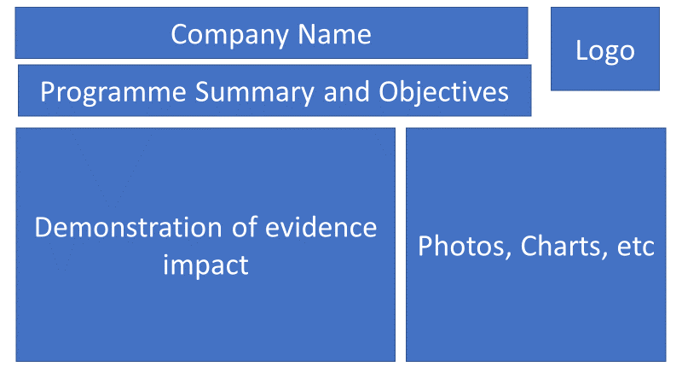

Why the Corporate Social Responsibility (CSR) Award?
Corporate Social Responsibility (CSR) is known by many names, such as Sustainability, Responsibility, or Corporate Communications, and has become an integral part of any corporation. What began as simple philanthropy has evolved into a vital business unit essential to corporate identity. Employees highly value a company's CSR actions when deciding where to work, and consumers often choose products based on how a company supports the community or the world at large. Companies recognise that attracting and retaining top talent depends on having an effective CSR programme and communicating it effectively to the world. CSR is now embedded into the mission of a company and is considered an essential part of its operations.
This award recognises a company operating in Taiwan that demonstrates excellence and innovation in its Corporate Social Responsibility (CSR) programme. The award is not dependent on a company’s size and is open to both local and foreign companies. The judges will evaluate not only the CSR programme itself but also how it is integrated into the business, and the benefits it brings to recipients, employees, and the wider network of stakeholders.
Entries will be assessed by our Judging Panel of leading experts based on the following criteria:
- Concise Summary: A brief summary of the company/individual, including objectives and culture.
- Business Story: A concise outline of the business story, highlighting achievements.
- Visible Initiatives: Clearly visible initiatives relevant to the selected awards category.
- Impact Evidence: Evidence of the impact of these initiatives in transforming the organisation and beyond.
This award is open to companies of all sizes, both local and foreign. It considers not only the innovation project but also how it integrates into the business and benefits recipients, employees, and a wider network of stakeholders.

Judging Criteria
The judges will look for applications demonstrating success across the following areas:

- Mission
  - Excellent vision and strategic direction.
  - Clear leadership and management of the organisation.
  - How CSR is embedded into the company’s mission.
  - The connection between CSR and the company’s core business.
- Evaluation of Impact
  - Benefits of the programme to both the recipients and the company.
  - Demonstrated measurable impact on a specific community, whether geographic or community-based.
  - Short-term and long-term impacts.
  - Inclusion of robust quantitative and qualitative evidence.
  - Utilisation of an evaluation process to improve its work.
  - Clear evidence of social, environmental, and community impact.
- Sustainability of Programme
  - Evidence that the programme can be replicated or scaled up.
  - Evidence of the long-term sustainability of the programme internally and its impact.
- Communication and Innovation
  - How CSR is communicated throughout the company’s stakeholder network.
  - Effective communication of its impact in accessible and creative ways.
  - Evidence of innovations employed in any of the above processes.

The judging panel will shortlist three companies from all entrants. The same panel will select a winning company, which will be announced at the Award Event on 25th September 2024.

How to Submit
Organisations can submit up to two pieces of supporting evidence, explicitly referred to or linked within the submission. Evidence can be attached to the submission form or emailed along with it.
Submissions may include hyperlinks to internal or external websites within the word limit if relevant.
The content of the submission and evidence should cover activities that have taken place within the 24 months preceding the award deadline.
Email your application to BBAMarketing@bcctaipei.com by Friday, 16 August 2024.

