BCCT Better Business Awards
Social Enterprise Award - Taiwan 2021 Guidance and Criteria
- Please answer the criteria in the space provided – the space will expand as you type
- Please provide any supporting documents as separate attachments when you send this application in.
- Please answer the criteria in the space provided in English or Chinese – the space will expand as you type.

Social Enterprise Award – Application

Company Name (English/Chinese):

Company Website:

Contact Person

Name:

Email:

Phone Number:
1 | Please indicate which category of United Nations Sustainable Development Goals your company is applying for:  Goal 1: No Poverty  Goal 2: Zero Hunger  Goal 3: Good Health and Well-Being for People  Goal 4: Quality Education  Goal 5: Gender Equality  Goal 6: Clean Water and Sanitation  Goal 7: Affordable and Clean Energy  Goal 8: Decent Work and Economic Growth  Goal 9: Industry, Innovation, and Infrastructure  Goal 10: Reducing Inequalities  Goal 11: Sustainable Cities and Communities  Goal 12: Responsible Consumption and Production  Goal 13: Climate Action  Goal 14: Life Below Water  Goal 15: Life on Land  Goal 16: Peace, Justice and Strong Institutions  Goal 17: Partnerships for the Goals
2 | Please provide evidence on how your Social Enterprise demonstrates an innovative product or service solution: (Limit of 700 words)
3 | Please provide evidence on how your Social Enterprise is a sustainable and feasible business model: (Limit of 700 words)
4 | Please provide evidence on how your Social Enterprise demonstrates realistic economic value and social impact: (Limit of 700 words)
5 | Please provide evidence on how your Social Enterprise demonstrates transparent supply chain and governance: (Limit of 700 words)
6 | One-page PowerPoint Slide on your CSR programme objective for presentation (see template below)

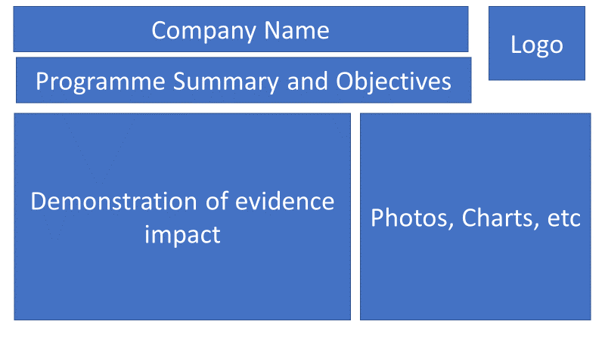

Why a Social Enterprise Award?

Social Enterprise, it uses business methods to solve problems in society and despite the seriousness, many are thriving with as many reporting growth last year as conventional businesses in the world.

Social enterprise is a world trend. Social enterprises are a kind of social innovation, and effectively solve social or environmental problems via a sustainable business model. The major purpose of social enterprise is to pursue public interest and solve social problems. It doesn’t rely on government grants or donations from the private sector. The development of social enterprise in Taiwan is still in the early stages but is getting wide attention. Creating a suitable social business development environment requires public, enterprise, and government to work together. Only in this way we can encourage social enterprise in continuous innovation and steady growth.

A Social Enterprise Award, open to Taiwan-based social enterprises (company limited or company limited by shares) and under the banner of the British Chamber of Commerce in Taipei Business Awards, will provide a great platform to celebrate and share the achievements and learning from organisations in this important area. This will not only leverage KPMG’s professional experience in audit, finance, tax and advisory service, but also involve the professional

consulting and incubation program via connecting our clients’ network. It can create more business opportunities to carry out the cooperation between social enterprises, profit-organizations and potential investors.
We suggest that submissions can be made in the form of a team submission, but all have to be made under the name of a specific company.

Categories

We suggest that nominations/entries can be made under one of the United Nations Sustainable Development Goals:
Goal 1: No Poverty
Goal 2: Zero Hunger
Goal 3: Good Health and Well-Being for People
Goal 4: Quality Education
Goal 5: Gender Equality
Goal 6: Clean Water and Sanitation
Goal 7: Affordable and Clean Energy
Goal 8: Decent Work and Economic Growth
Goal 9: Industry, Innovation, and Infrastructure
Goal 10: Reducing Inequalities
Goal 11: Sustainable Cities and Communities
Goal 12: Responsible Consumption and Production
Goal 13: Climate Action
Goal 14: Life Below Water
Goal 15: Life on Land
Goal 16: Peace, Justice and Strong Institutions
Goal 17: Partnerships for the Goals

Criteria

1. Innovative product or service solution (30%)
2. Sustainable and feasible business model (30%)
3. Realistic economic value and social impact (20%)
4. Transparent supply chain and governance (20%)

How to Submit
• Organisations can submit up to 2 pieces of supporting evidence, explicitly referred/linked to the submission. Evidence can be attached to the submission form or emailed along with it.
• The nominations may include hyperlinks to internal/external websites within the word limit submission if relevant to it.
• The content of the submission and evidence will need to cover activity that has taken place within the 24 months preceding the award deadline.
Email your application to BBAMarketing@bcctaipei.com by Friday 6 August 2021.

