BCCTaipei Better Business Awards
Business Leader of the Year Award - Taiwan 2023 Guidance and Criteria
- Please answer the criteria in the space provided – the space will expand as you type
- Please provide any supporting documents as separate attachments when you send this application in.
- Please note that this Award is focus on Individuals but not for Companies.
- Please answer the criteria in the space provided in English or Chinese – the space will expand as you type.

Business Leader of the Year Award – Application

Contact Person

Name:

Company Name (English/Chinese):

Company Website:

Email:

Phone Number:
1 | Please provide a concise summary of the business leader including personal objectives and impact: (limit to 500 words)
2 | Please provide examples of leadership within your organisation and /or the community that has clearly identified a vision and set of values towards diversity, social enterprise, sustainability and promoting cross border economic activity within your services, policies, process and/or approaches: (limit to 1000 words)
3 | Please highlight two (or more) innovative initiatives, projects, programmes or service for staff/customers/partners and importantly, the broader community that has attracted positive feedback, and where appropriate, improved outcomes and created lasting impact: (Limit of 1000 words)
4 | Please provide evidence of the impact of these initiatives in transforming your organisation and beyond (Limit of 600 words)
5 | One-page PowerPoint Slide on your Corporate Social Responsibility (CSR) programme objective for presentation (see template below)
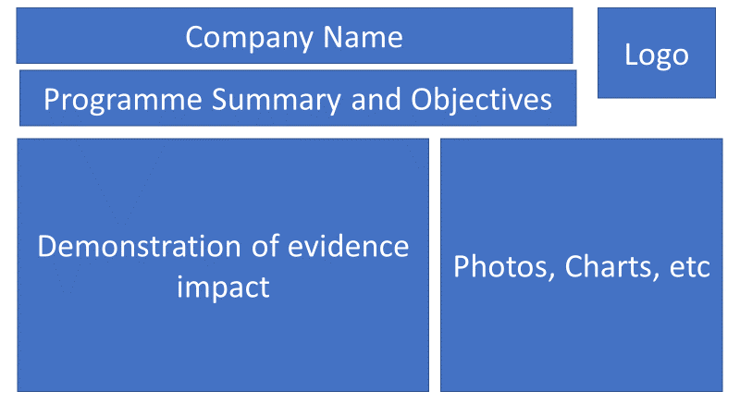

Why a Business Leader Award?
HSBC prides itself as being an institution aligned to the highest standards; spanning our products and services, but also importantly, our leadership in supporting the community and cultivating positive economic development. The sponsorship of an award to recognise a business leaders significant achievement covering diversity & inclusion, social enterprise, sustainability and promoting cross border economic relations is at the core of what we stand for.

Categories
Admissions will consider the following categories:

Making a Leadership Contribution & Innovation in Diversity & Inclusion

Social Enterprise
- Sustainability
- Improving cross border economic relations

Judging Process
- Entries are assessed by our Judging Panel of leading experts in their area on the following criteria:
  - Concise summary of the individual including objectives and culture
  - Concise outline of the success story including achievements
  - Clearly visible initiatives undertaken which are relevant to the selected awards category
  - Evidence of the impact of these initiatives in transforming the community, your organisation and beyond

Category One – Making a Leadership Contribution & Innovation in Diversity & Inclusion
A diverse and inclusive workforce is critical to running a sustainable and successful business. A business leader should aim to harness the benefits of diverse teams to drive greater innovation, better identify and manage risks, enhance collaboration and improve workforce agility.
Diversity and inclusion principles form part of everything an organisation does, helping to attract, develop and retain the best people and build an inclusive environment for everyone, free from bias and discrimination.
This category invites submissions for a business leader who has consistently demonstrated leadership in relation to the advancement of the diversity and inclusion agenda within his/her organisation.

The Judges will be looking for an application that shows success across the following areas of Diversity:
− The nominee champions diversity and inclusion through notable initiatives, actions and role model behaviour to build a diverse and inclusive environment.
− Evidence of the impact of these diversity and inclusion initiatives in transforming the business organisation and beyond

Category Two – Social Enterprise
Social enterprise is a world trend, using business methods to solve problems in society and despite the seriousness, many are thriving with as many reporting growth last year as conventional businesses in the world. A business leader should aim to drive innovative product or service solutions and create a suitable social business development environment.
This category invites submissions for a business leader who has consistently demonstrated leadership in relation to the advancement of the social enterprise agenda within his/her organisation.

The Judges will be looking for an application that shows success across the following areas of Social Enterprise
- The nominee champions social enterprise through a sustainable business model, initiatives, actions and role model behaviour to pursue public interest and solve social or environmental problems.
- Evidence of the impact of these social enterprise initiatives in demonstrating realistic economic value and social or environmental solution.

Category Three – Sustainability
Corporate Social Responsibility (CSR) is an increasingly important part of any company and becomes the vision and strategic direction how company runs business. A business leader should aim to drive CSR programmes relevant or integrated into business and demonstrate social, environmental, or community impact on a specific community.

This category invites submissions for a business leader who has consistently demonstrated leadership in relation to the advancement of the CSR agenda within his/her organisation.
The Judges will be looking for and application that shows success across the following areas of Sustainability
- The nominee champions CSR through innovative programmes, initiatives and actions to connect company’s regular business, communicate with stakeholders and provide social, environmental, or community impact.
- Evidence of the impact of these CSR initiatives in demonstrating the long-term sustainability in social, environmental and community impact.

Category Four - Improving cross border economic relations
Consistent with the mission of the British Chamber of Commerce and the role of multinational organisations operating in Taiwan, we are here to bring the world to Taiwan and also support economic growth for Taiwanese companies abroad.
This category strives to identify unique and talented individuals who have demonstrated exceptional commitment to drive both inbound and outbound economic growth for Taiwan.
The Judges will be looking for an application that shows success across the following areas of Improving cross border economic relations
- The nominee champions cross border economic relations through innovative programmes, initiatives and actions to connect their company and the broader business community with opportunities both in Taiwan and aboard, stimulating positive economic development.
- Evidence of the impact of these initiatives in demonstrating the long-term sustainability in economic activity and opportunities for business and individuals alike, to thrive.

How to Submit
- Individuals can submit up to 2 pieces of supporting evidence covering each category, explicitly referred/linked to the submission. Evidence can be attached to the submission form or emailed along with it.
- The nominations may include hyperlinks to internal/external websites within the word limit submission if relevant to it.
- The content of the submission and evidence will need to cover activity that has taken place within the 24 months preceding the award deadline.
Email your application to BBAMarketing@bcctaipei.com by Friday 4 August 2023.

