BCCTaipei Better Business Awards
Corporate Social Responsibility Award - Taiwan 2023 Guidance and Criteria
- Please answer the criteria in the space provided – the space will expand as you type
- Please provide any supporting documents as separate attachments when you send this application in.
- 本次申請資料中英文皆可受理，英文為主中文為輔。

Corporate Social Responsibility Award – Application

Company Name (English/Chinese):

Company Website:

Contact Person

Name:

Email:

Phone Number:
1 | Please provide examples of how CSR is embedded into the mission of the company and illustrate a connection between CSR and the company’s core business: (limit to 500 words)
2 | Please provide quantitative and qualitative evidence on how the CSR programme at your company has demonstrated social, environmental, or community impact on a specific community. Judges will be looking for focus on real outcomes and measurable impact, rather than only activities: (Limit of 1000 words)
3 | Please provide evidence of how you will keep running this programme in your company for long-term sustainability and continued (internal) impact: (Limit of 600 words)
4 | Please show how your CSR programme is communicated through your stakeholder network in accessible and innovative ways: again, Judges will be focusing on real outcomes and measurable impact rather than only activities. (limit to 500 words)
5 | One-page PowerPoint Slide on your CSR programme objective for presentation (see template below)
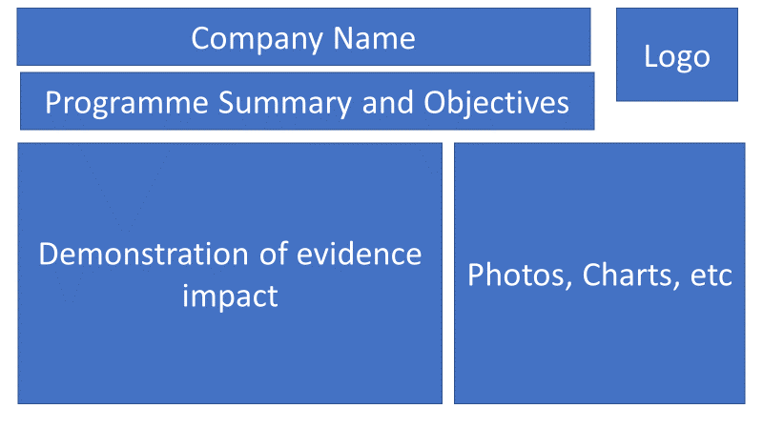

Why a Corporate Social Responsibility Award?
Corporate Social Responsibility (CSR) has many names (Sustainability, Responsibility, Corporate Communications, etc.) and is an integral part of any corporation. From the early days of Philanthropy, CSR has now become an integrated business unit vital to any corporate identity. Employees place great importance on a company’s CSR actions in their decision to work for that company. Consumers decide on what products they will buy based on how a company is supporting the community or the world at large. Companies know that attracting the best talent - and retaining that talent - is reliant on their company having not only a great CSR programme but also on how they communicate that programme to the world. CSR is integrated into the mission of a company and is no longer seen as something “other” or additional.
This award is to recognize a company operating in Taiwan that demonstrates excellence and/or innovation in their Corporate Social Responsibility (CSR) programme. The award is not dependent on a company’s size and is open to local and/or foreign companies. The judges will consider not only the CSR programme that a company runs but also how that programme is relevant and integrated into the business as well as the benefits that it brings to the recipients, the employees, and the wider network of stakeholders.

Judging Process
- Entries are assessed by our Judging Panel of leading experts in their area on the following criteria:
  - Concise summary of the company/individual including objectives and culture
  - Concise outline of the business story including achievements
  - Clearly visible initiatives undertaken which are relevant to the selected awards category
  - Evidence of the impact of these initiatives in transforming your organisation and beyond

The Judges will be looking for an application that shows success across the following areas of CSR:
- Mission
  - Excellent vision and strategic direction
  - Clear leadership and management of the organisation
  - The way CSR is embedded into the mission of the company
  - The connection between CSR and the company’s core business
- Evaluation of impact
  - The benefits of the programme to both the recipient and to the company
  - Demonstrated measurable impact on a specific community, be it geographic or community based
    - Short term impact
    - Long-term impact
  - Includes good quantitative and qualitative evidence
  - Utilizes an evaluation process to improve its work
  - Clear evidence of one or all of social, environmental, and community impact
- Sustainability of Programme
  - Evidence that the programme can be replicated or scaled up
  - Evidence of the long-term sustainability of the programme internally and its impact
- Communication and Innovation
  - How CSR is communicated throughout the company stakeholder network
  - Has communicated its impact in accessible and creative ways
  - Evidence of innovations that have been employed in any of the above processes

How to Submit
- Organisations can submit up to 2 pieces of supporting evidence, explicitly referred/linked to the submission. Evidence can be attached to the submission form or emailed along with it.
- The nominations may include hyperlinks to internal/external websites (keeping within the word limit) if relevant to the application.
- The content of the submission and evidence will need to cover activity that has taken place within the 24 months preceding the award deadline.
Email your application to BBAMarketing@bcctaipei.com by Friday 4 August 2023.

