BCCTaipei Better Business Awards
Innovation for Wellbeing Awards
Taiwan 2023 Guidance and Criteria
- Please answer the criteria in the space provided – the space will expand as you type
- Please provide any supporting documents as separate attachments when you send this application in.
- Please answer the criteria in the space provided in English or Chinese – the space will expand as you type.

Innovation for Wellbeing Award – Application

Company Name (English/Chinese):

Company Website:

Contact Person:

Name:

Email:

Phone Number:
1 | Please provide a concise summary of the innovation for wellbeing including objectives and impact: (limit to 500 words)
2 | Please provide quantitative and qualitative evidence on how this innovation has demonstrated the positive impact to improve people’s wellbeing. Judges will be looking for focus on outcomes and impact, rather than only activities: (Limit of 1000 words)
3 | Please provide evidence of the long-term sustainability of this innovation internally and externally and its impact (Limit of 600 words)
4 | Please show how this innovation is communicated through your stakeholder network in accessible and innovative ways: Judges will be focusing on outcomes and impact rather than only activities. (Limit to 500 words)
5 | One-page PowerPoint Slide on your innovation for wellbeing summary for presentation (see template below)
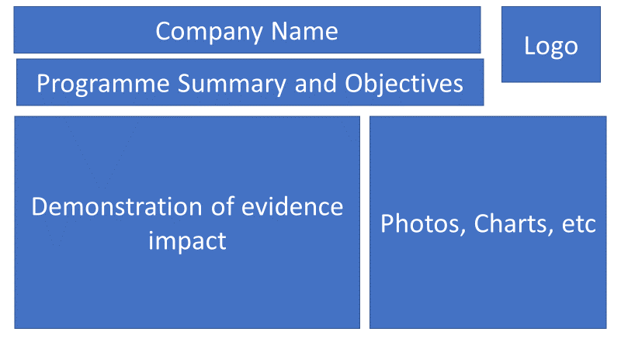

Why the Innovation for Wellbeing Award?
As a leading insurer aiming to help people get the most out of life, PCA Life Taiwan focuses on digitalized or innovative solutions to make health and financial security accessible. By delivering the best solutions, we are committed to making positive impacts on our customers and our communities.
The Innovation for Wellbeing Award supports our purpose to help people get the most out of life and will focus on the criteria below.
- The issues to be solved should focus on “wellbeing (health and/or wealth).”
- Solutions ideally serve the public interests or assist vulnerable groups and should not be limited to employees
- This award recognizes companies that develop innovative solutions including but not limited to new products, platforms, services etc. to enhance people’ health, wealth, wellbeing and sustainability in Taiwan.
- The solutions should be accessible, affordable, approachable and actionable for their targeted users. Accessible refers to easy access, affordable refers to perceived values of target users, approachable refers to stakeholders’ interests and actionable refers to tools/platforms for target user to utilize actively.
The award is not dependent on a company’s size and is open to local and/or foreign companies. It will consider not only the innovation project that a company runs but also how that innovation is relevant and integrated into the business and the benefits that it brings to the recipients, the employees, and the wider network of stakeholders.

Judging Process
- Entries are assessed by our Judging Panel of leading experts in their area on the following criteria:
  - Concise summary of the company/individual including objectives and impact:
  - Concise outline of the business story including achievements
  - Clearly visible initiatives undertaken which are relevant to the selected awards category
  - Evidence of the impact of these initiatives in transforming your organization and beyond
- A shortlist of three companies will be selected by our judging panel from all entrants, and the same judging panel will select a winning Company which will be announced at the Award Event on 27th September 2023

The Judges will be looking for and application that shows success across the following areas of Innovation for Wellbeing Award:
- Evaluation of Objective and Impact
  - The connection between Digital Innovation and the company’s regular business
  - Initiatives aligned with the goal of innovation for wellbeing, improve wellbeing and help people to live healthier and happier
  - Demonstration of short term and long-term impact
- Evaluation of quantitative and qualitative evidence
  - The benefits of the initiative to the industry, the company, and stakeholders
  - Evidence of this innovation that have been employed
  - Includes good quantitative and qualitative evidence
- Sustainability of Programme
  - Evidence that the programme can be replicated or scaled up
  - Evidence of the long-term sustainability of the programme externally and internally and its impact

- Communication and Innovation
  - How this innovation is communicated throughout the company stakeholder network
  - Has communicated its impact in accessible and creative ways

How to Submit
- Organizations can submit up to 2 pieces of supporting evidence, explicitly referred/linked to the submission. Evidence can be attached to the submission form or emailed along with it.
- The nominations may include hyperlinks to internal/external websites within the word limit submission if relevant to it.
- The content of the submission and evidence will need to cover activity that has taken place within the 24 months preceding the award deadline.

Email your application to BBAMarketing@bcctaipei.com by Friday 4 August 2023.

