BCCTaipei Better Business Awards
Climate Champion Award 2023 Guidance and Criteria
- Please answer the criteria in the space provided – the space will expand as you type
- Please provide any supporting documents as separate attachments when you send this application in.
- Please complete the form in English and Chinese.
- Please ensure you refer to actions taken over the December 2022 – December 2023 period.

Climate Champion Award – Application

Company Name (English/Chinese):

Company Website:

Estimated number of staff:

Contact Person

Name:

Email:

Phone Number:
1 | What has your company done to reduce its carbon footprint? This could be an invention, application, product, service, or process. (200 words)  a. What results were achieved following this? (200 words)
2 | Has your company helped raise stakeholder awareness on climate action (e.g., through trade associations, think tanks/research institutions, industry groups), or worked to influence its supply chains? (200 words)  2a. What results were achieved following this? (200 words)
3 | Does your company have an environmental strategy and is it embedded within your overall business strategy/brought to the board level? (200 words)
4 | Is your company a member of Race to Zero, EV100, RE100, Powering Past Coal Alliance (PPCA) or following Task Force on Climate-Related Financial Disclosures’ (TCFD) recommendations?  Please Select: None / Race to Zero / EV100 / RE100 / PPCA / TCFD
5 | Have you won any previous awards or recognition for climate action and for what achievements? (200 words)
6 | One-page PowerPoint Slide on your climate action work for presentation (see template below)

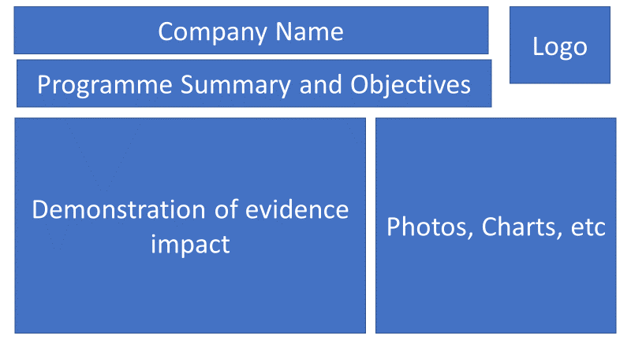

Why the Climate Champion Award?
The BCCTaipei Better Business Climate Champion Award will be presented to a company operating in Taiwan that has taken significant steps to reduce its carbon footprint and acted as a leader in climate action.
The science is clear: if we wish to limit the global temperature rise to 1.5° C, we should be working towards net zero emissions by 2050 at the latest. We are looking for ways in which companies have reduced emissions and actively worked to help our planet reach this goal.
The UK is a global leader in climate action. We wish to also highlight one company in Taiwan that has, similarly, acted as a climate leader over the 2021-2022 period. We are looking for companies that have embedded climate action into all aspects of their business operations. This could be through raising awareness with stakeholders, working with supply chains and partners to reduce their carbon footprint, bringing climate action to the board level, or joining specific climate-related initiatives.
This is the first award of its kind that Eiger Law has sponsored. It is a unique opportunity to highlight your company’s climate leadership. Our judging panel will select the final winner, and the winner will be promoted through the British Chamber of Commerce in Taipei as the Better Business Awards 2022 Climate Champion.

We encourage companies present within Taiwan of all sizes, British and non-British, to apply.

Judging Process
Companies will be evaluated on their performance, including any ongoing projects in Taiwan from December 2021 - December 2022. Submissions and evidence must cover activity within this time frame.
We are looking for specific actions that companies have taken towards:
- Reducing their carbon footprint
- Acting as a climate leader
Applications should include clear evidence of the impact of actions taken.
Applications will be assessed by a board consisting of Eiger Law staff and independent business leaders.
Email your application to BBAMarketing@bcctaipei.com by Friday 4 August 2023.

